St. Francis Institute of Technology, Mumbai-400 103

**Department of Information Technology**

A.Y. 2024-2025

Class: TE-ITA/B, Semester: V

Subject: **Advanced DevOps Lab**

**Experiment – 2: To understand the benefits of Cloud Infrastructure and create AWS Cloud9 EC2 development environment and run python code in the environment.**

1. **Aim:** To understand the benefits of Cloud Infrastructure and create AWS Cloud9 EC2 development environment and run python code in the environment.
2. **Objectives:** After study of this experiment, the student will be able to
   * Understand basic cloud9 IDE
   * Perform Collaboration for Projects.
3. **Outcomes:** After study of this experiment, the student will be able to
   * Understand cloud computing service Cloud9 IDE and collaboration facility provided by cloud9
4. **Prerequisite:** Fundamentals of cloud computing
5. **Requirements:** PC and Internet
6. **Pre-Experiment Exercise:**

**Brief Theory:**

AWS Cloud9 is a cloud-based integrated development environment (IDE) that lets you write, run, and debug your code with just a browser. It includes a code editor, debugger, and terminal. Cloud9 comes prepackaged with essential tools for popular programming languages, including JavaScript, Python, PHP, and more, so you don’t need to install files or configure your development machine to start new projects. Since your Cloud9 IDE is cloud-based, you can work on your projects from your office, home, or anywhere using an internet-connected machine. Cloud9 also provides a seamless experience for developing serverless applications enabling you to easily define resources, debug, and switch between local and remote execution of serverless applications. With Cloud9, you can quickly share your development environment with your team, enabling you to pair program and track each other's inputs in real time.

**CODE WITH JUST A BROWSER**

AWS Cloud9 gives you the flexibility to run your development environment on a managed Amazon EC2 instance or any existing Linux server that supports SSH. This means that you can write, run, and debug applications with just a browser, without needing to install or maintain a local IDE. The Cloud9 code editor and integrated debugger include helpful, time-saving features such as code hinting code completion, and step-through debugging. The Cloud9 terminal provides a browser- based shell experience enabling you to install additional software, do a git push, or enter commands.

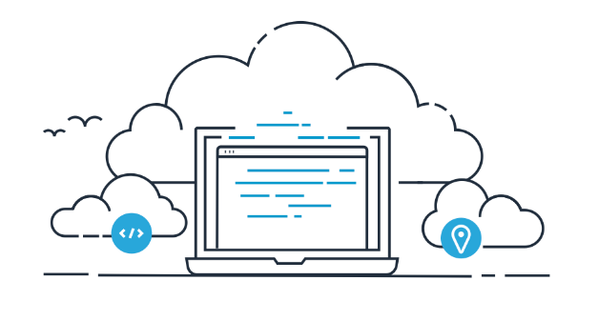

**CODE TOGETHER IN REAL TIME**

AWS Cloud9 makes collaborating on code easy. You can share your development environment with your team in just a few clicks and pair program together. While collaborating, your team members can see each other type in real time, and instantly chat with one another from within the IDE.

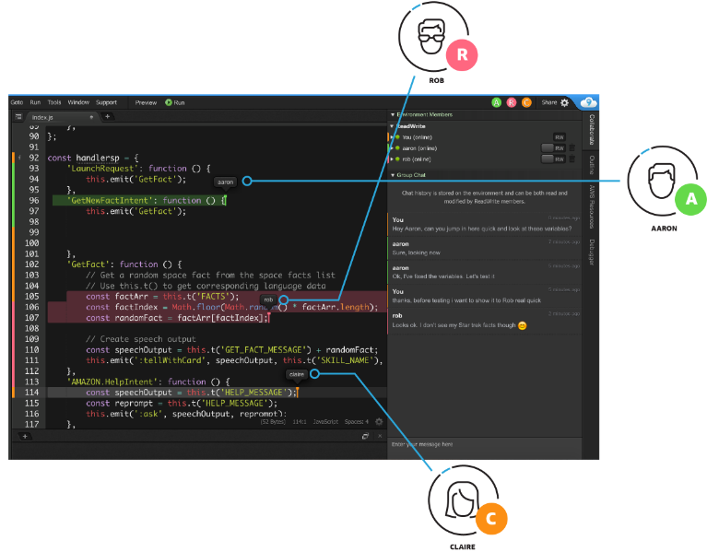

**BUILD SERVERLESS APPLICATIONS WITH EASE**

AWS Cloud9 makes it easy to write, run, and debug serverless applications. It preconfigures the development environment with all the SDKs, libraries, and plug-ins needed for serverless development. Cloud9 also provides an environment for locally testing and debugging AWS Lambda functions. This allows you to iterate on your code directly, saving you time and improving the quality of your code.

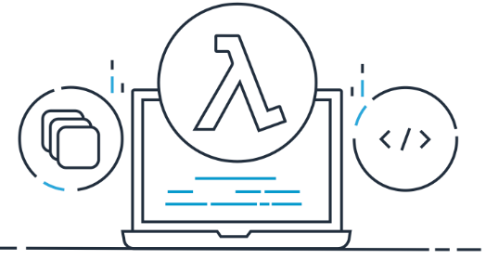

**DIRECT TERMINAL ACCESS TO AWS**

AWS Cloud9 comes with a terminal that includes sudo privileges to the managed Amazon EC2 instance that is hosting your development environment and a pre-authenticated AWS Command Line Interface. This makes it easy for you to quickly run commands and directly access AWS services

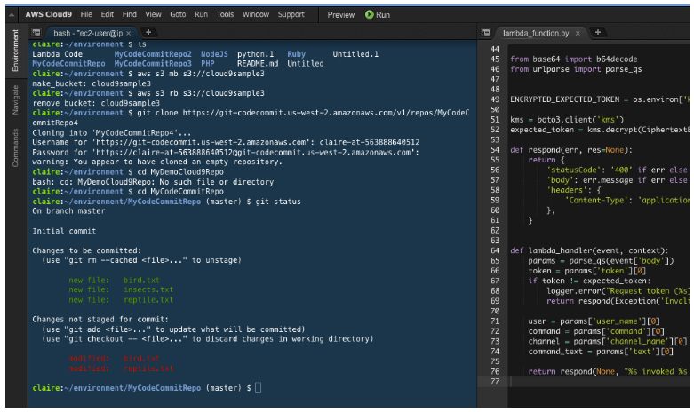

**START NEW PROJECTS QUICKLY**

AWS Cloud9 makes it easy for you to start new projects. Cloud9’s development environment comes prepackaged with tooling for over 40 programming languages, including Node.js, JavaScript, Python, PHP, Ruby, Go, and C++. This enables you to start writing code for popular application stacks within minutes by eliminating the need to install or configure files, SDKs, and plug-ins for your development machine. Because Cloud9 is cloud-based, you can easily maintain multiple development environments to isolate your project’s resources.

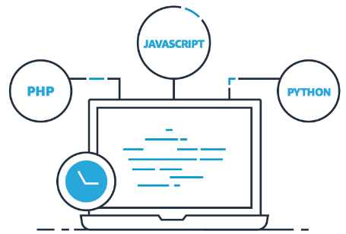

**How does AWS Cloud9 work?**

The following diagram shows a high-level overview of how AWS Cloud9 works.

From the diagram (starting at the bottom), you use the AWS Cloud9 IDE, running in a web browser on your local computer, to interact with your AWS Cloud9 environment. A computing resource (for example, an Amazon EC2 instance or your own server) connects to that environment. Finally, your work is stored in an AWS CodeCommit repository or other type of remote repository.

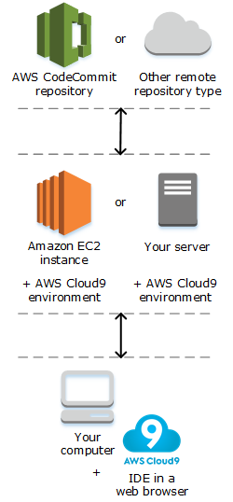

1. **Laboratory Exercise**

**Login with your AWS account.**

**Navigate to Cloud 9 service from Developer tools section as below:**

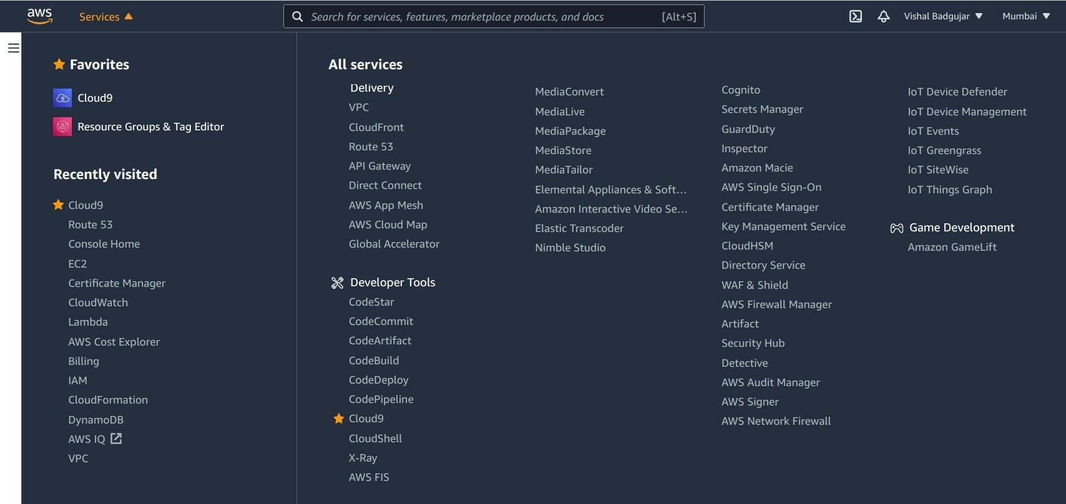

**3. Choose an AWS Region to create the environment in US East (N. Virginia) Region**

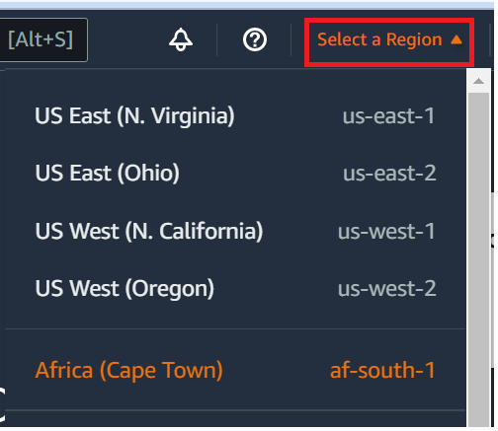

**3.Click on Create Environment :**

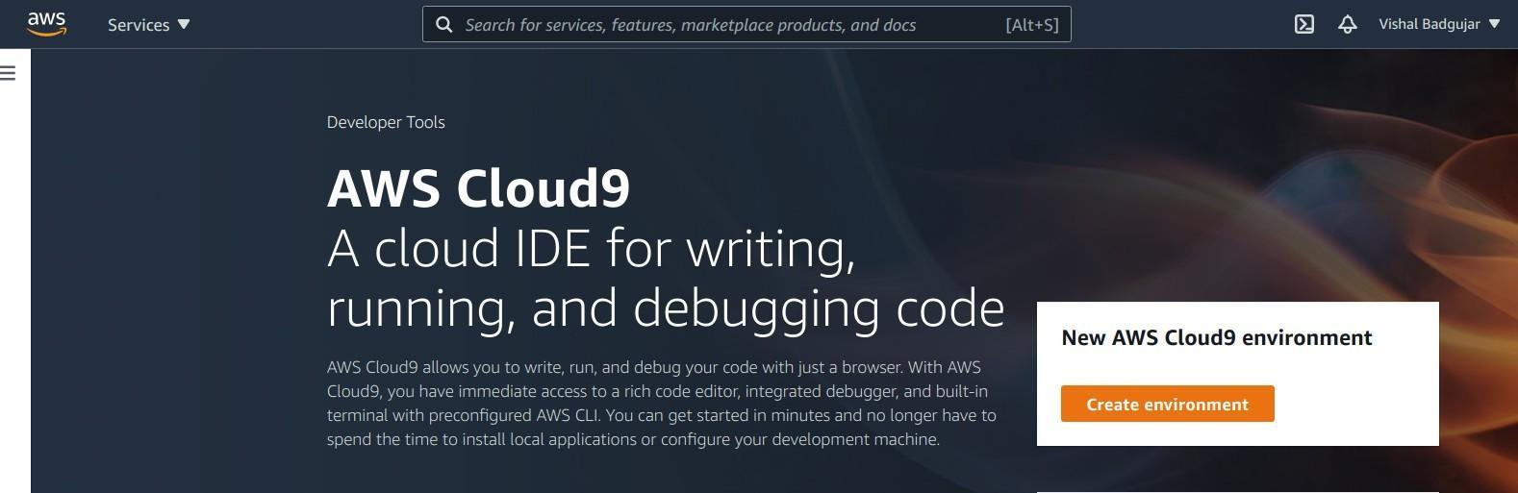

**4. Provide name for the Environment (WebAppIDE) and click on next:**

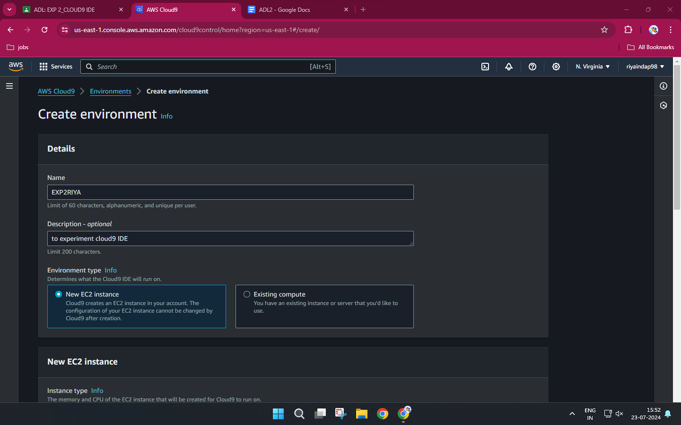

**5.Keep all the Default settings as shown in below:**

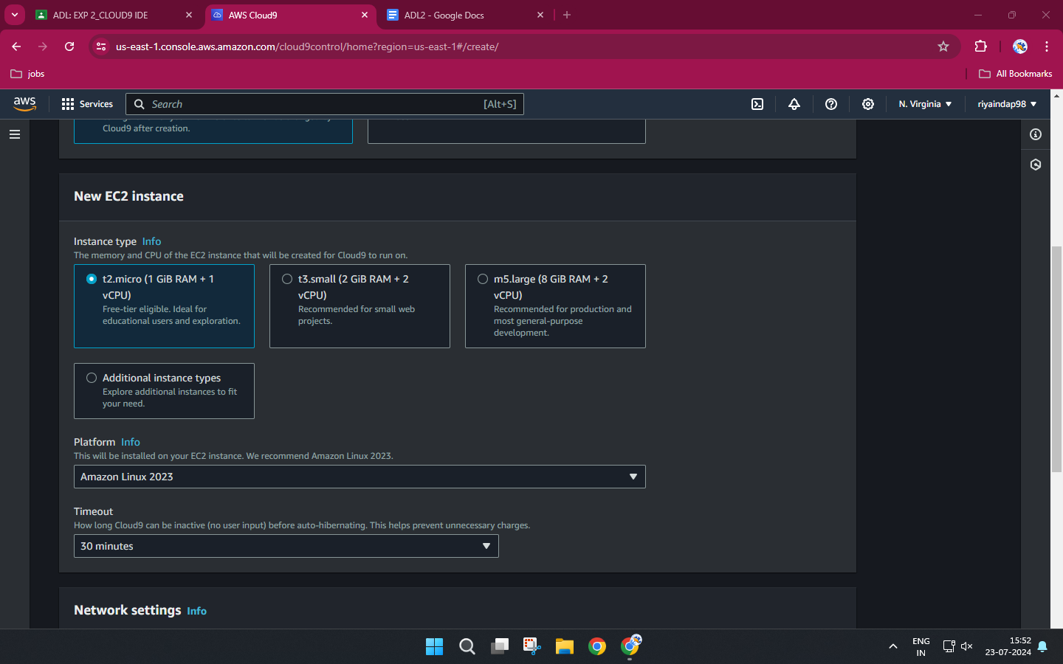

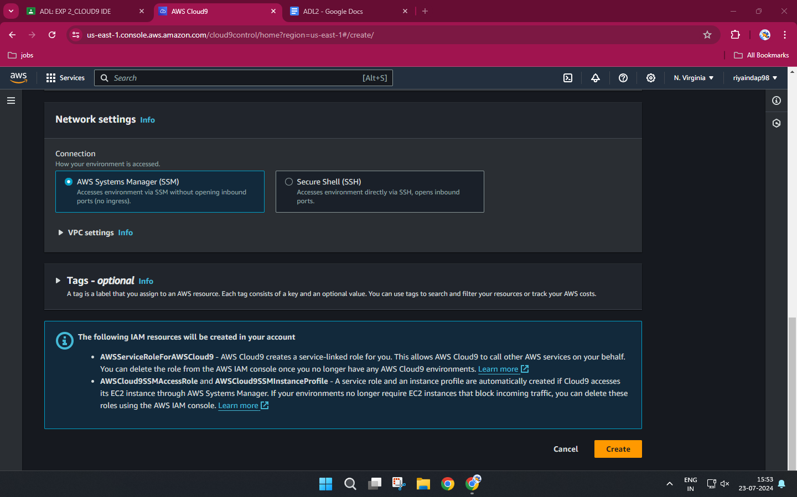

**6.Review the Environment name and Settings and click on Create Environment:**

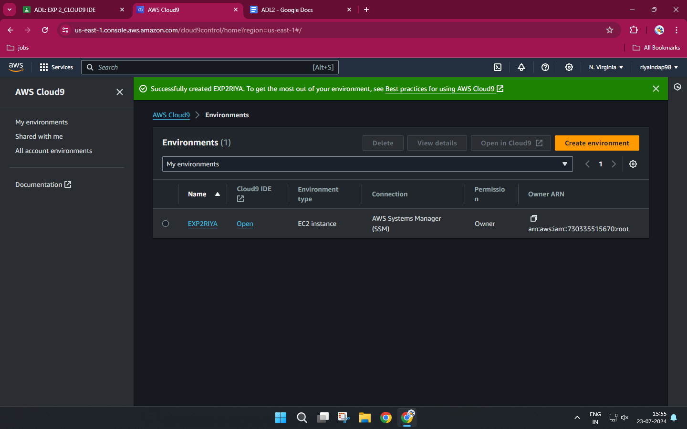

It will take a few minutes to create aws instance for your Cloud 9 Environment.

# 7.Till that time open IAM Identity and Access Management in order to Add User In other tab.

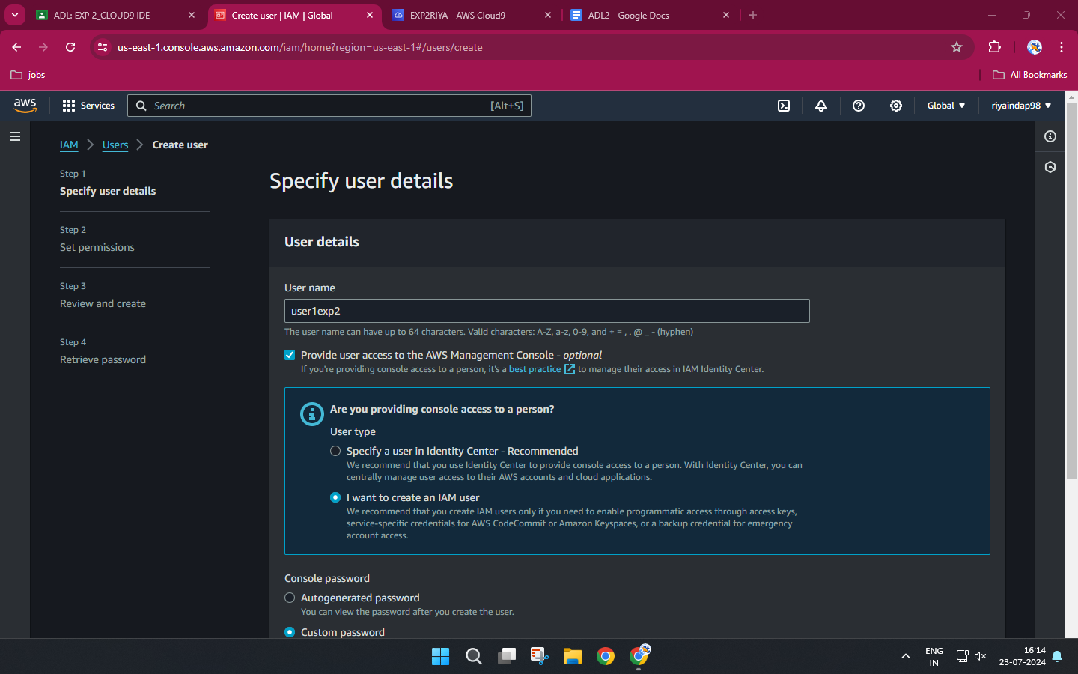

**8.Add user provide manual password if you want and click on Next permission tab.**

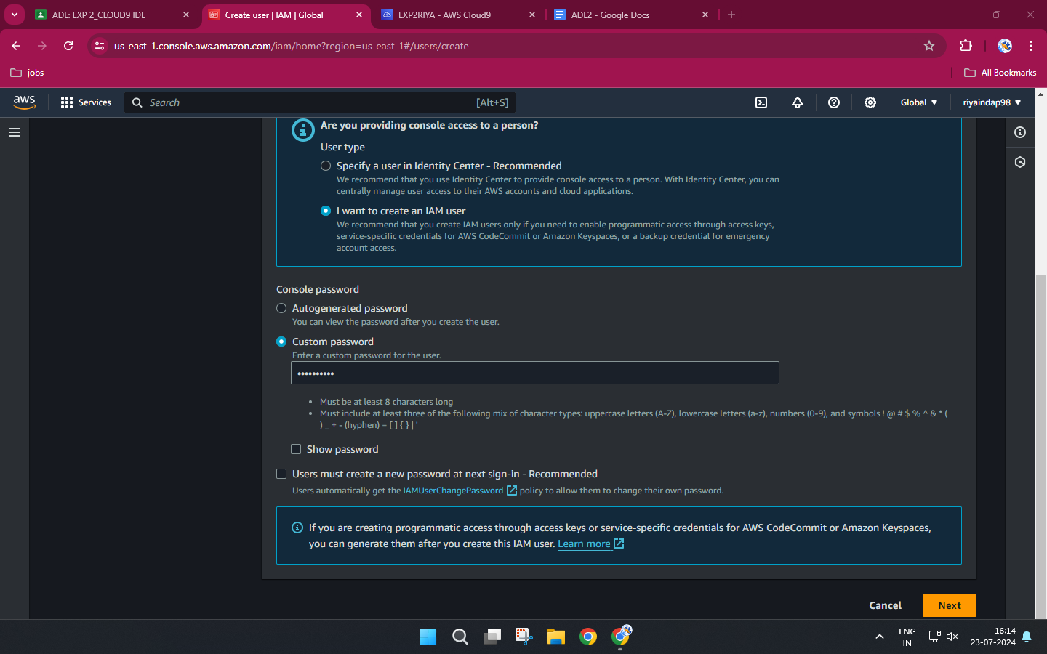

# 9.Click on Create group

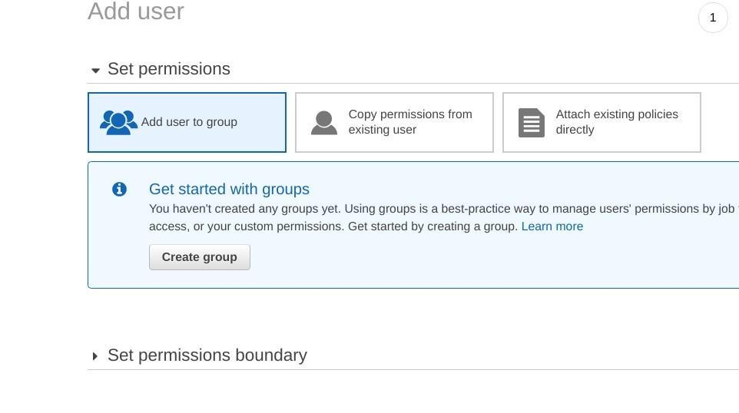

**10.Provide group name and click on create group.**

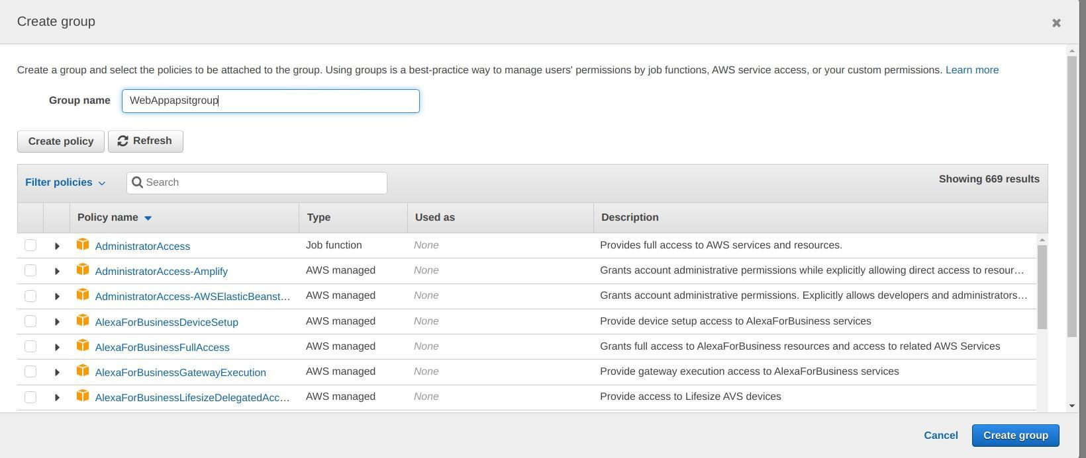

**11.After that group is created click on next if u want to provide tag else click on Review for user settings and click on create user as shown in fig.**

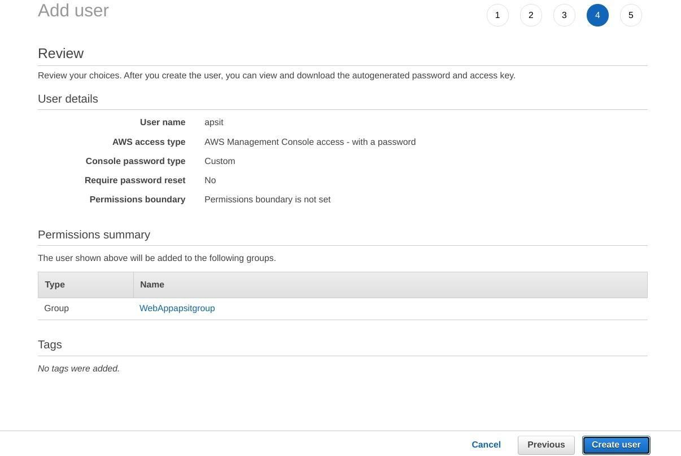

**12.Now close that window and Navigate to user Groups from left pane in IAM.**

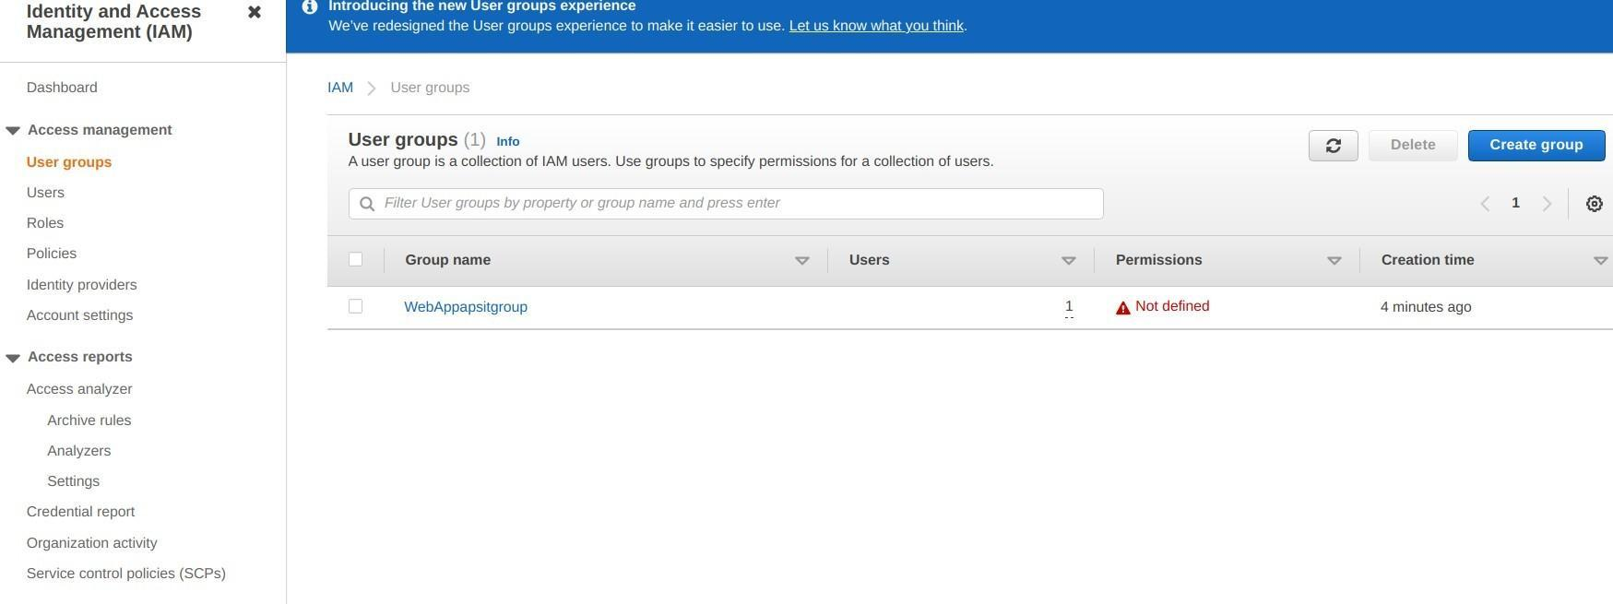

**13.click on your group name which you have created and nevigate to permission tab as shown:**

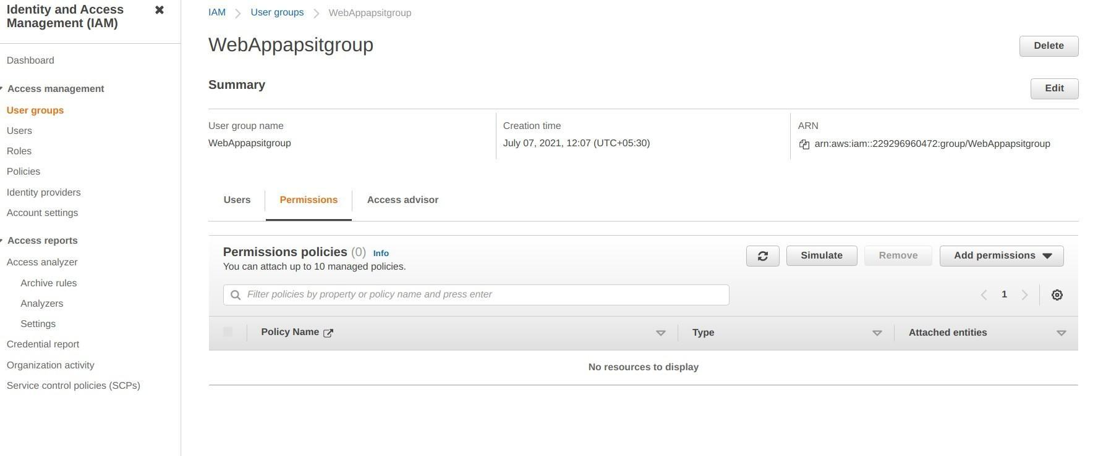

**14.Now click on Add permission and select Attach Policy after that search for Cloud9 related policy and select Awscloud9EnviornmentMember policy and add it.**

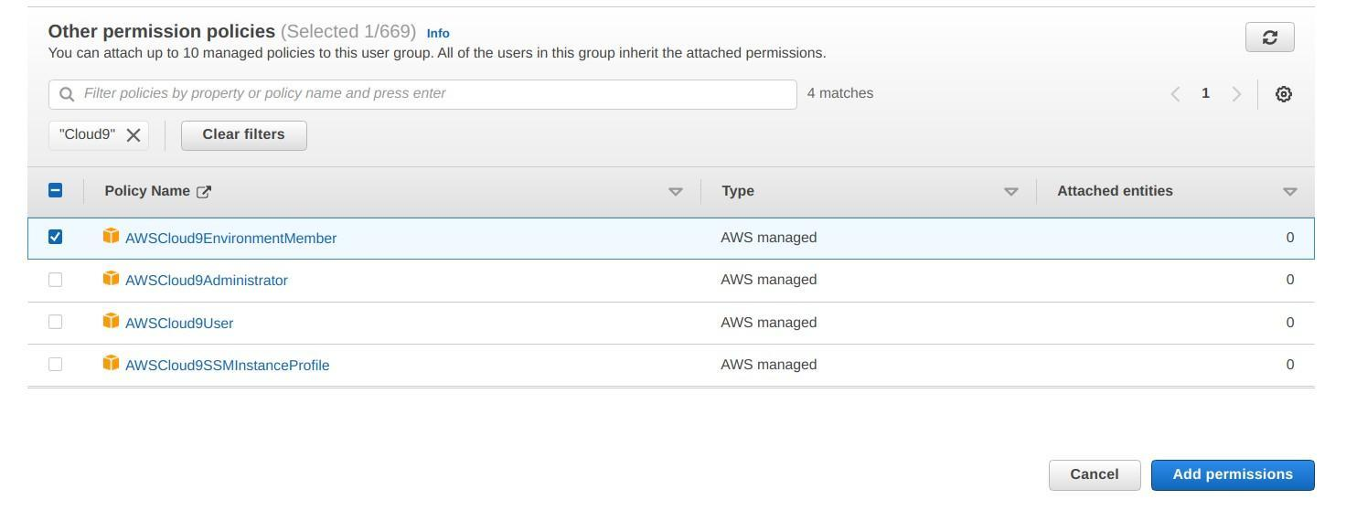

**15.now we move towards our cloud9 IDE Enviornment tab it shows as shown :**

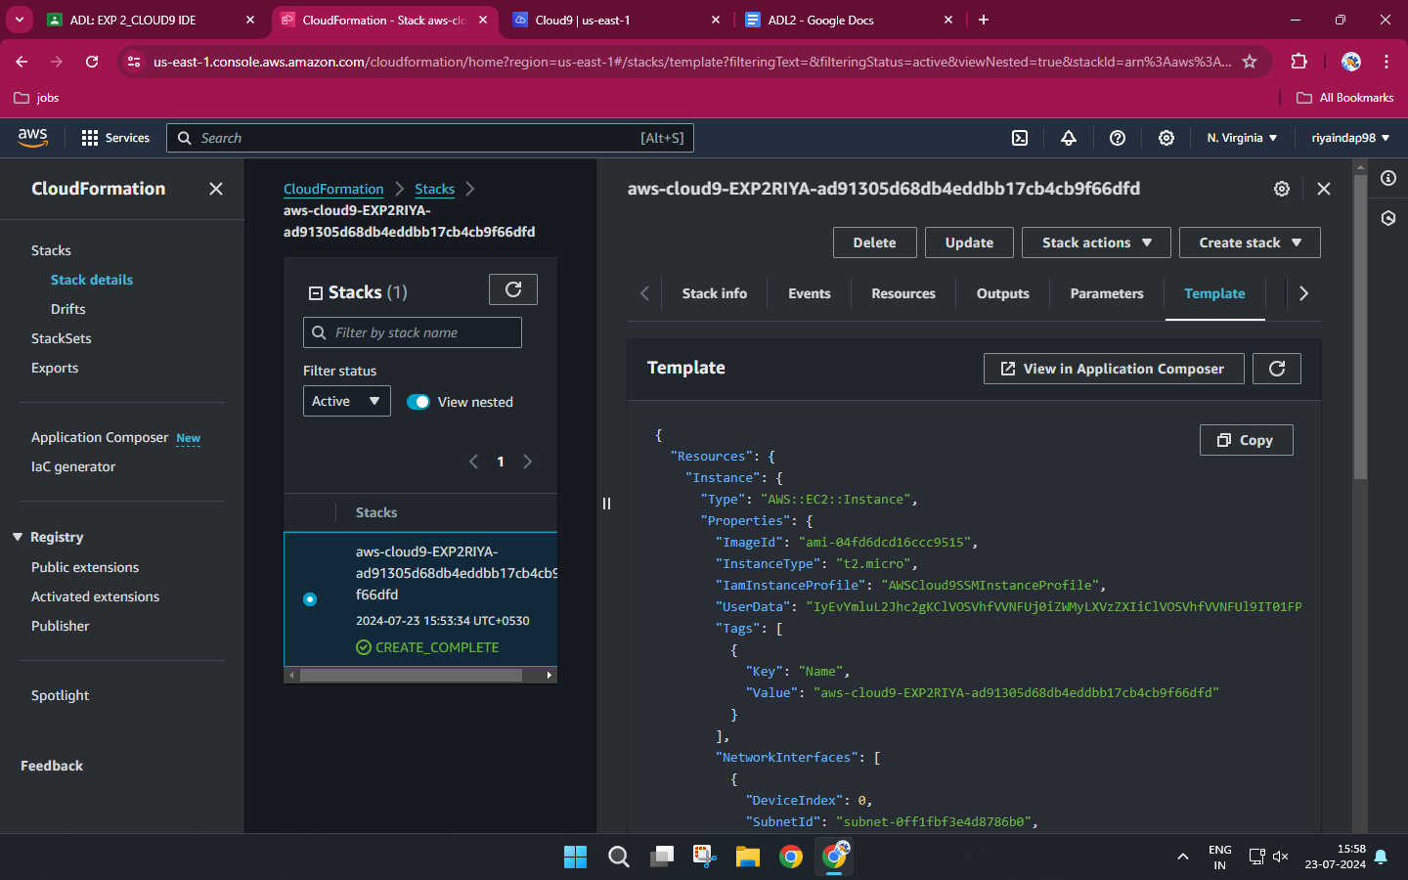

**16.If you check at bottom side Cloud9 IDE also giving you an aws CLI for command operations:**

**1. check git version git --version,** 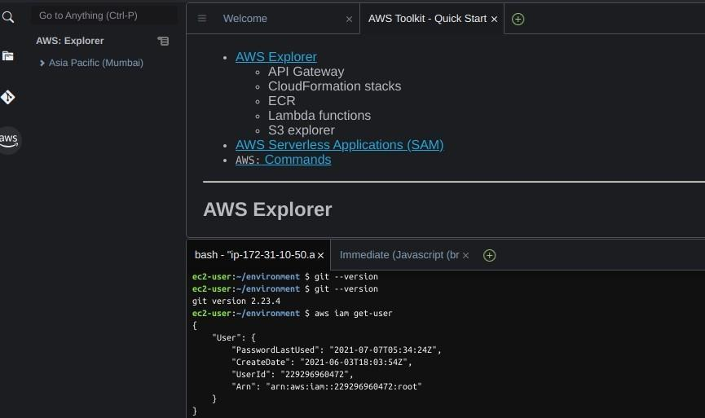

**2. java --version,**

**3. python - -version etc..**

**4. IAM user details with command aws iam get-user**

**17. Now we will setup collaborative enviornment Click on File you can create new file or choose from template, here m opting html file to collaborate.**

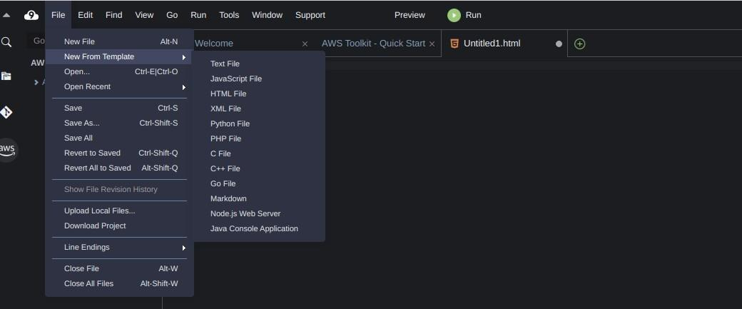

**17.Edit html file and save it**

**18.Now in order to share this file to collaborate with other members of your team click on Share option on Roght Pane and username which you created in IAM before into Invite members and enable persmission as RW (Read and Write) and click on Done. Click OK for Security warning.**

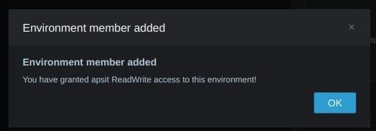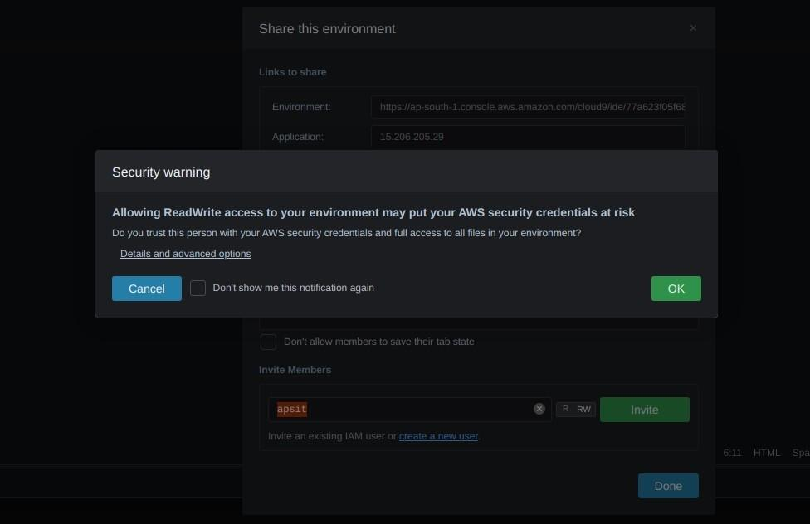

**19.Now Open your Browsers Incognito Window and login with IAM user which you configure before.**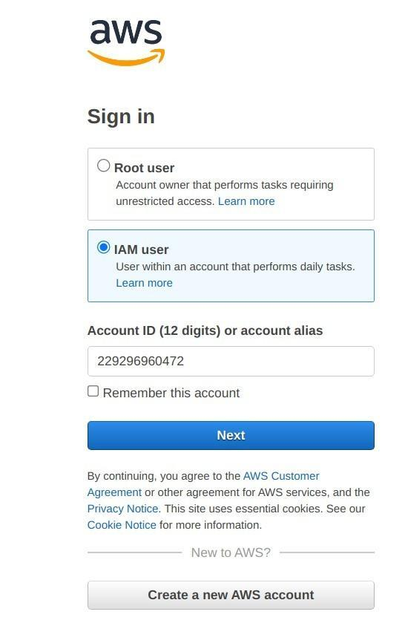

**20.After Successful login with IAM user open Cloud9 service from dashboard services and click on shared with you enviornment to collaborate.**

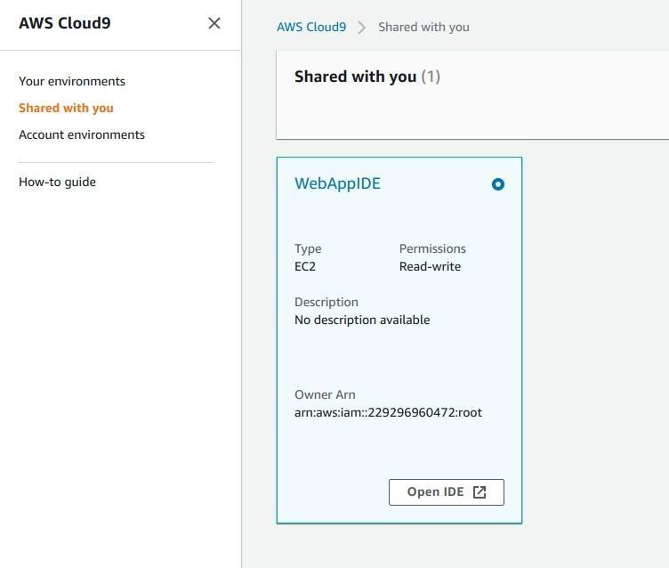

**21.Click on Open IDE you will same interface as your other member have to collaborate in real time, also you all within team can do group chats as shown below:**

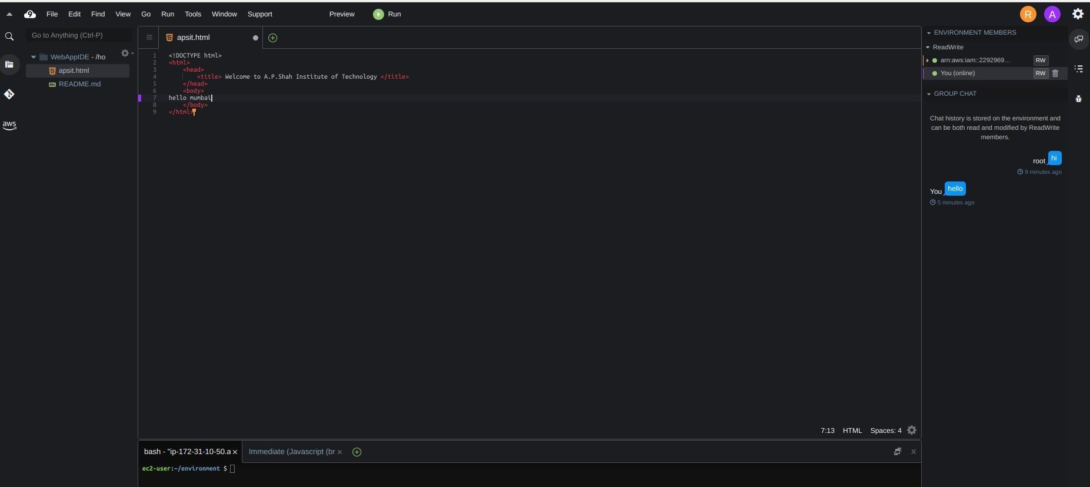

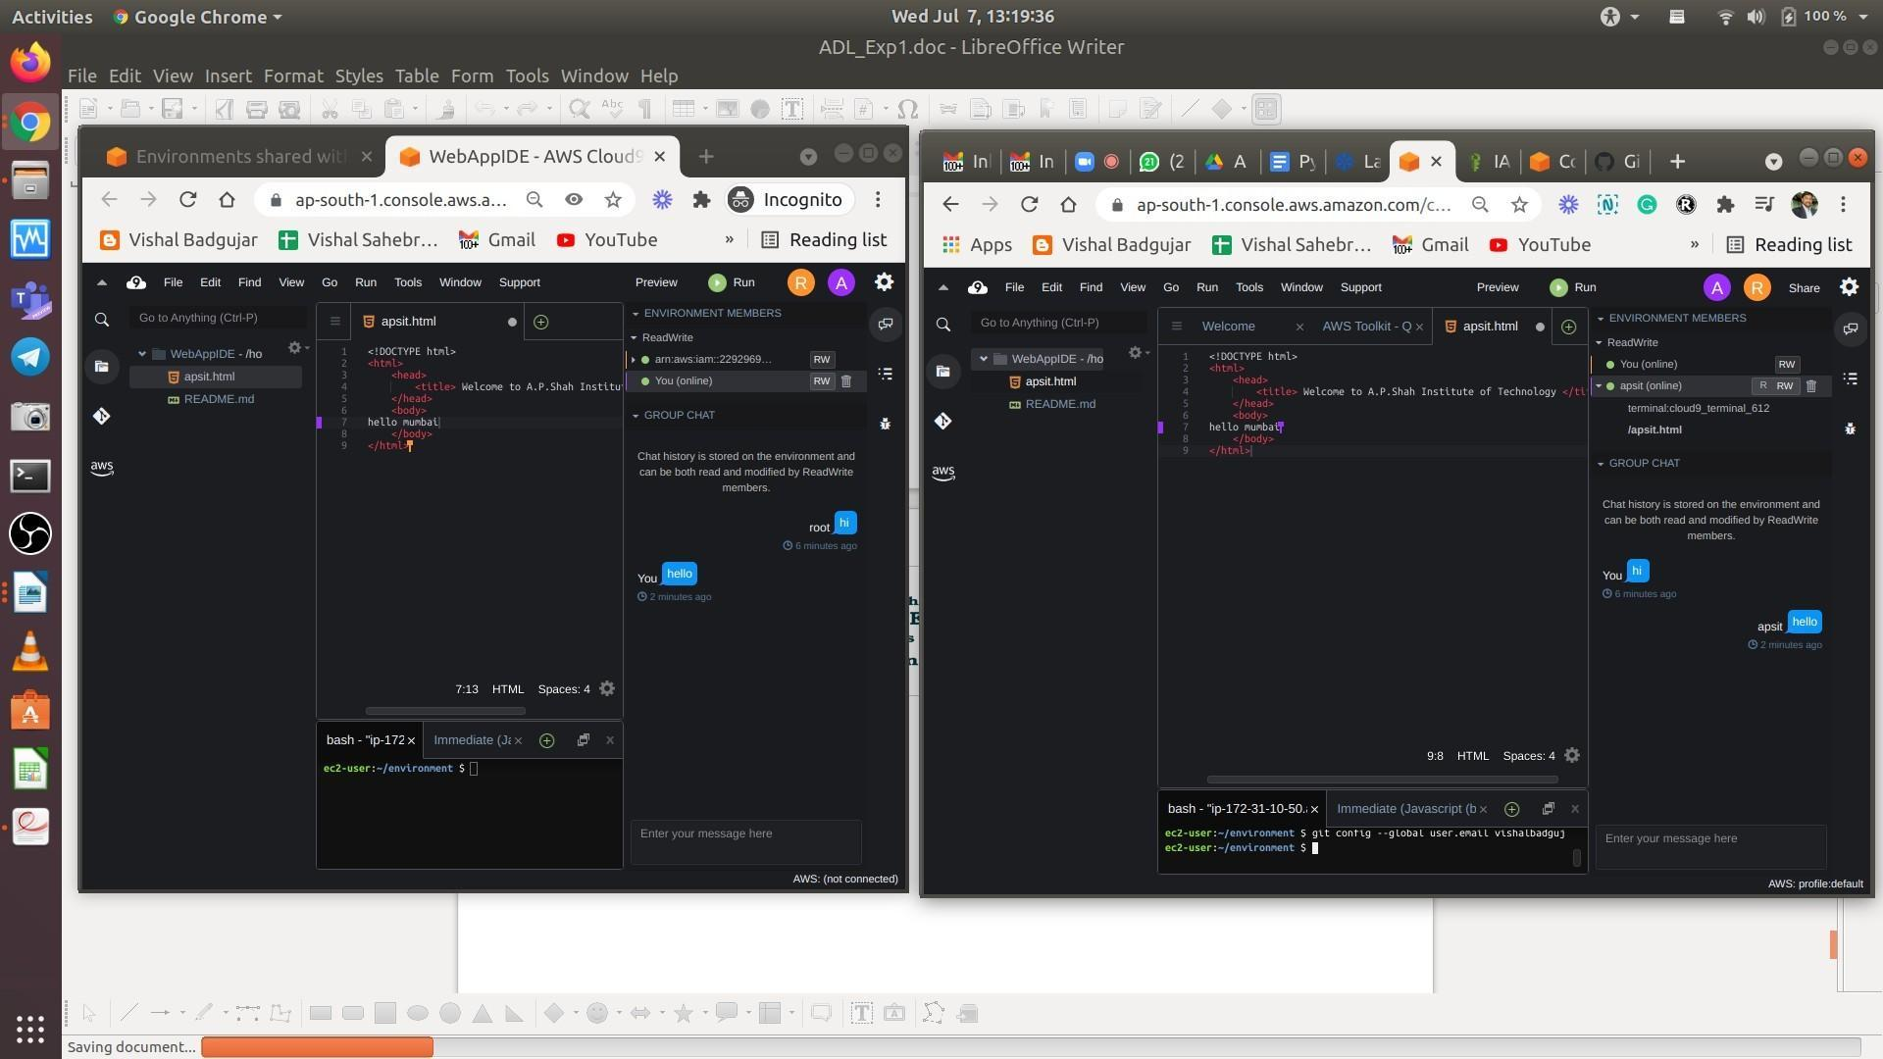

**23. You can also explore settings where you can update permissions of your teammates as from RW to R only or you can remove user too.**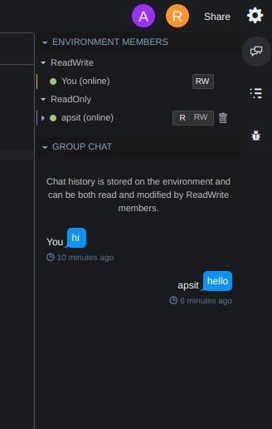

1. **Post-Experiments Exercise**
2. **Extended Theory:**

Use of AWS cloud9 with other AWS services.

1. **Questions:**
2. Which programming languages are supported by cloud9?
3. What are the types of AWS Cloud9 development environments?

**C. Conclusion:**

Write the significance of the topic studied in the experiment.

1. **References:**

<https://docs.aws.amazon.com/cloud9/latest/user-guide/aws-cloud9-ug.pdf>

<https://aws.amazon.com/cloud9/faqs/>